AWS Networking contd

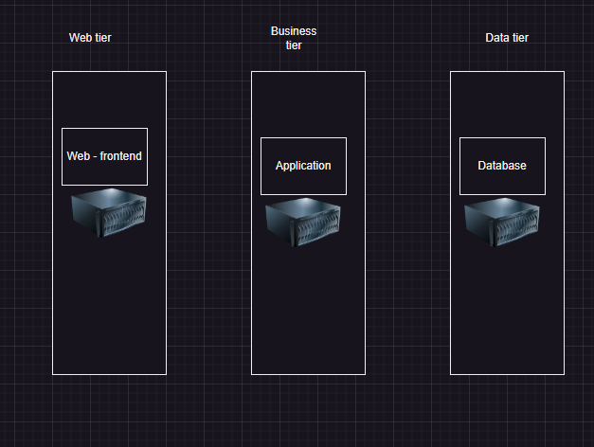 Lets look at ntier architecture

 Web tier should be publically accessible, whereas application and db tier should be private

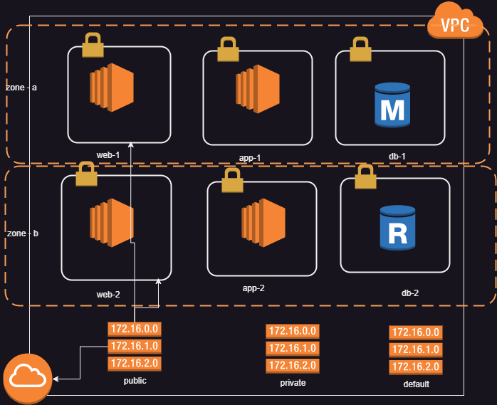 To design this in AWS the network will be as shown below

# Lets create a vpc according to the image shown above

 for screenshots refer classroom video

 Private subnet can get internet access with the help of NAT Gateway hosted in public subnet. Also modify the routes in private route table to forward the internet traffic (0.0.0.0/0) to NAT - Gateway.

# Egress only internet gateway

 Ingress means incoming traffic  Egress means outgoing traffic

 Egress only internet gateway is attached to the vpc where complete vpc is private and requires internet access

# Security Group

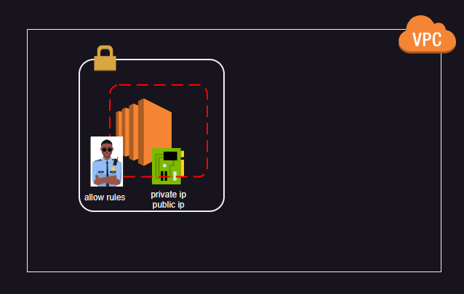[Refer Here](https://docs.aws.amazon.com/vpc/latest/userguide/vpc-security-groups.html) for official docs

Security group can filter the incoming network traffic based  source ip

 protocol:

 TCP  UDP

 icmp (ping)  port number

Restriction on the basis of source ip

A network interface (elastic network interface) can be connected to multiple security groups